E-Ark Web CMIS Repository Browser
The CMIS viewer is a web based simple tool for browsing a CMIS repository.
The tool is architecturally divided into two components, an angular-js based UI which communicates via RESTful interface to a Java built backend as is illustrated in the diagram below.
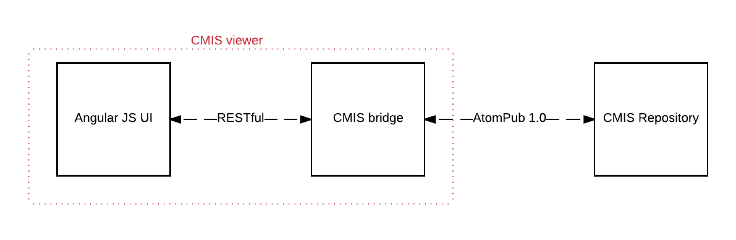

Use case and feature description summary
The short list of features for the CMIS browser are as follows:
- Authenticate users
- Switch interface language
- Configure CMIS repository connection parameters
- Add/create new users to access the viewer
The simple interface of the browser is depicted in the image below..
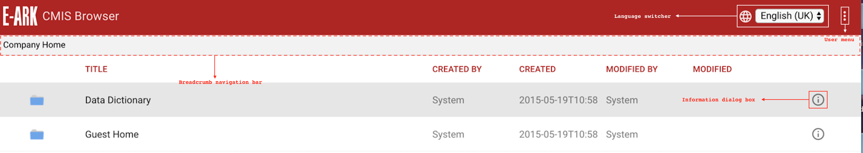

Authentication and user authorisation
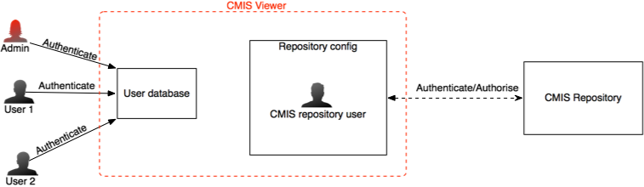
Users are authenticated against the CMIS viewer’s user database, NOT against the CMIS repository itself. In fact the relation between the user and the datasource (the CMIS repository) is two tiered, both in terms of authentication and authorisation and is depicted in the image below.
As mentioned earlier, the CMIS viewer recognises two types of authority, an ADMIN user and a STANDARD user. The difference is simply that additional system configuration menus are exposed to the ADMIN user under the user menu, otherwise user interaction with the repository browser is the same.
The relation between the CMIS viewer and the target CMIS repository is through a valid user that is recognised by the CMIS repository, as such this user must be present within the CMISs’ repository own user database. The implication of this relationship between the viewer and the CMIS repository means that, all users of the CMIS repository browser are constrained by the authorisation of this user with regards to the user’s authorisation on CMIS repository itself; therefore the CMIS repository browser has no effect whatsoever on the CMIS repository itself. One should think of the CMIS viewer as a simple reader with read only rights on CMIS repository.

Configuring CMIS viewer repository connection
An administrator account is required to be able to modify the CMIS repository connection configuration. This menu is accessible from the user menu.

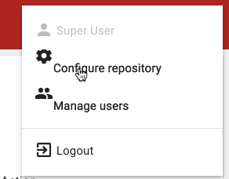
1.
2.

One should then arrive at the repository configuration menu which looks like the image below:
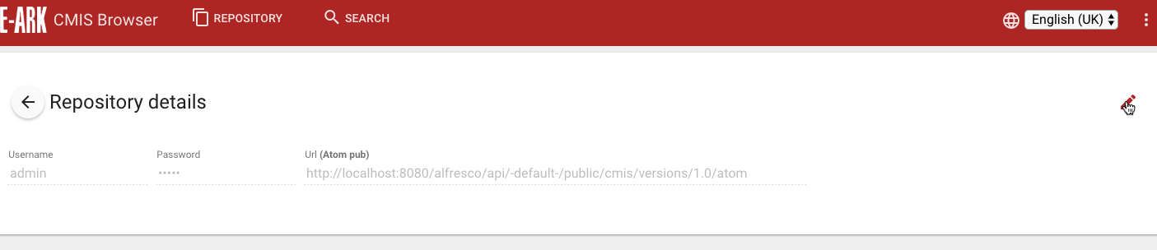

Clicking the pen icon as shown in the picture above will result in the fields becoming editable and a save button appearing on the bottom right corner of the screen as shown in the next picture below:
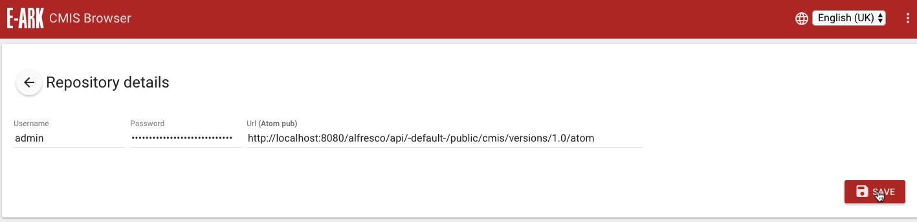
Again one should remember that the “user name” and “password” fields must match an authorised user in the CMIS repository itself; so all users browsing the CMIS repository will do so under authorisation of the user details saved here. The Url field MUST be an Atompub 1.0 url.
After saving, one can then click on the “←Repository details” button to go back to the repository browsing view.

Browsing and getting around
After the initial login to the browser, the user is directed to the repository browsing view which should like the image below:
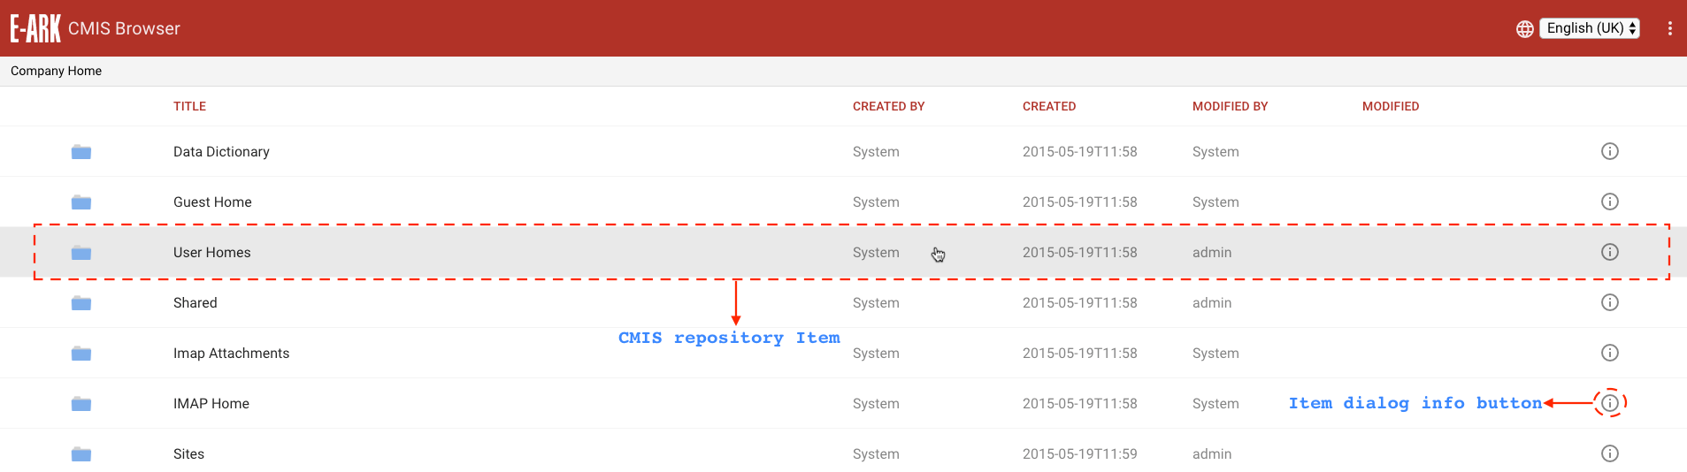
Mousing over a repository item highlights it as the current selection as can be seen in the image above, and clicking anywhere on the line except the item’s dialog information button would result in the following actions:
- if the item is a directory, the view will refresh to display its contents.
- If the item is a file then a new window is opened where the user is prompted to download and save the file unto the local system. If the user’s browser has a plugin to view the file, for example a pdf, then the file is displayed in the newly opened window instead. The user still has an option to download the file in this previewed window.
When the dialog information button is clicked, a dialog pops up to display the item’s metadata similar to the picture below:
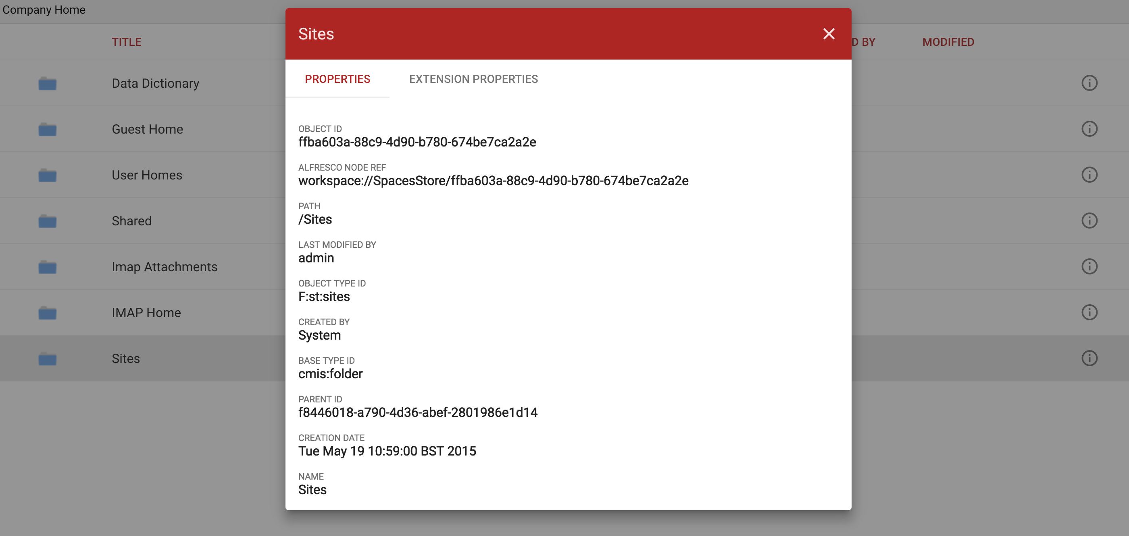
The item metadata dialog is split into two panes:
- Properties pane which displays the standard CMIS properties of the item and
- Extension properties pane which displays the extension properties of the item; if any.

User Management
Managing users involves creating, deleting and editing a user’s details in the viewer. This is the only other feature that is available to an administrator aside from the “Repository Configuration” feature.
Just like the repository configuration menu, this menu is also accessible from the user menu:
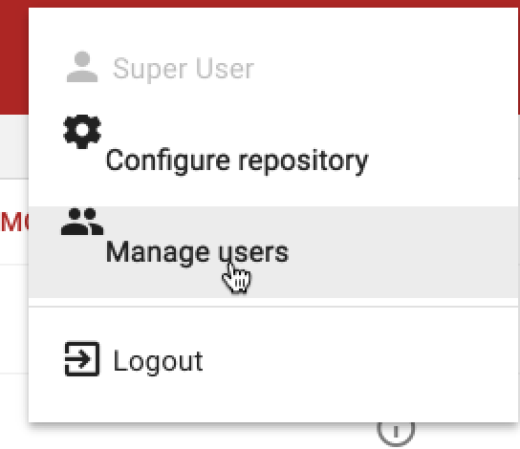

The user management screen should look similar to the picture below (minus the illustrations)
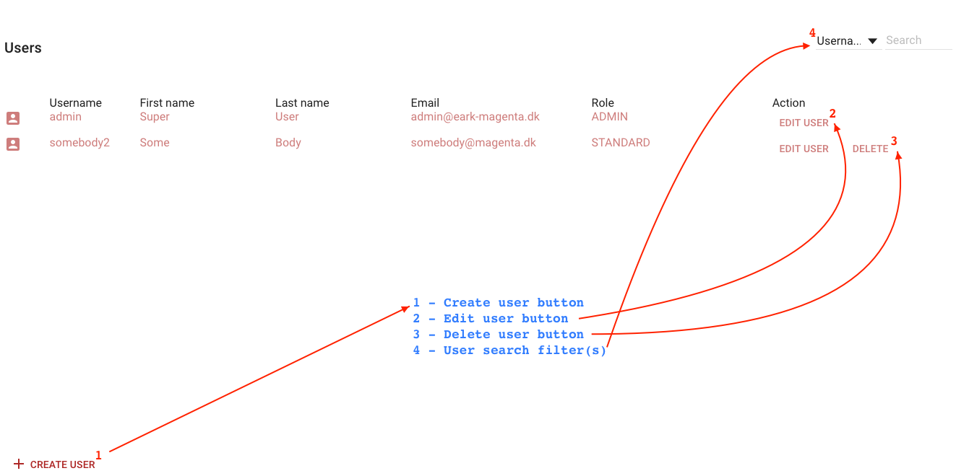

We believe that for the most part the interface is fairly intuitive so not every function possible in this interface will be described.
Management of a user happens interactively through the user dialogs and is pretty much self explanatory:
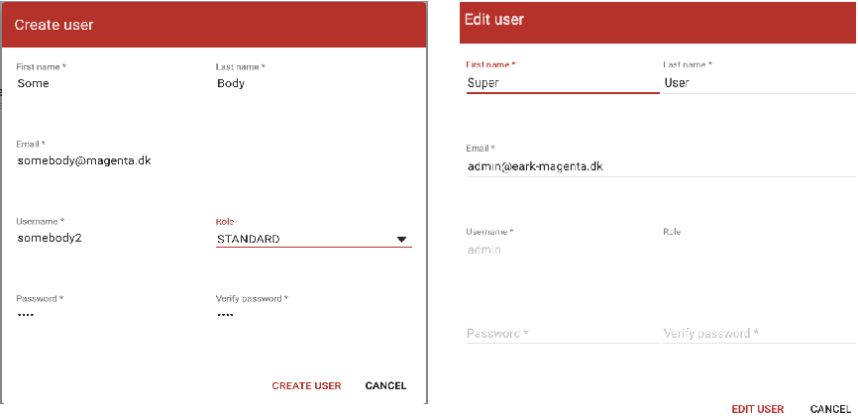
When editing a user, the Username field is non modifiable, and in the case of the primary admin user (i.e. the user with the “admin” username), both the username and the roles are non-modifiable.
With regards to deleting a user, all users except the primary admin user are deletable.

